Arifcan Karaser
DSA210 Final Report
Macroeconomic Drivers of Luxury Watch Prices: A Machine Learning Approach

1. Motivation
The luxury watch market is often described as a store of value, a wearable asset class that operates at the intersection of craftsmanship, brand prestige, and macroeconomic forces. As a data science student with a personal interest in both financial markets and horology, I have always questioned what truly drives the price appreciation of iconic timepieces. Are prices simply a function of brand perception, or do they respond systematically to global financial indicators such as gold prices, inflation, and stock market performance?

This project investigates the quantitative relationship between macroeconomic variables and luxury watch prices across a 20-year period (2005–2024). Rather than relying on subjective assessments of brand value, I sought to determine whether objective financial indicators could serve as reliable predictors of watch price movements across 35 iconic models from brands including Rolex, Patek Philippe, Audemars Piguet, Richard Mille, and others.

Three core research questions guide this study:

- Safe-Haven Asset Behavior: Does the luxury watch market mirror traditional safe-haven assets such as gold, with prices rising in tandem during periods of economic uncertainty?
- Market Segmentation: Can K-Means clustering identify distinct behavioral clusters — entry-level luxury, premium, ultra-high-net-worth — based solely on financial behavior?
- Predictive Power: Can a Random Forest Regressor trained on macroeconomic indicators accurately predict luxury watch prices, and which factors carry the most predictive weight?

The resulting model achieves an R² of 0.9429, confirming that macroeconomic variables are powerful and statistically significant drivers of luxury watch prices.

2. Data Source and Feature Engineering

2.1 Macroeconomic Data
- Gold Price (Gold_USD): Annual average gold price in USD per troy ounce — the primary safe-haven benchmark.
- S&P 500 Index: Annual closing values representing U.S. large-cap equity performance and global investor risk appetite.
- Nasdaq Index: Technology sector performance and high-growth market sentiment.
- U.S. CPI Index: Consumer Price Index (base 2005 = 100) measuring cumulative inflation.
- BIST100 USD: Istanbul Stock Exchange 100 Index in USD capturing emerging market dynamics.

2.2 Watch Price Data
Annual retail prices (USD) were tracked for 35 models over 2005–2024, covering four market tiers:
- Ultra-Luxury: Patek Philippe Nautilus & Calatrava, Audemars Piguet Royal Oak, Richard Mille RM011.
- Premium: Rolex Submariner, Daytona, GMT-Master II; Hublot Big Bang; IWC Portugieser; Panerai Luminor.
- Entry-Level Luxury: TAG Heuer Carrera, Longines Master Collection, Tissot Le Locle, Hamilton Khaki Field.
- Accessible: Seiko Prospex, Seiko 5 Sports, Casio G-Shock.

2.3 Feature Engineering
- Data Merging: Finance data pivoted to wide format and merged with watch data on Year key (688 rows total).
- Missing Value Imputation: Mean imputation per column to preserve sample size consistency.
- Cluster Feature: K-Means cluster label added as an engineered feature for the Random Forest model.

3. Hypothesis Testing

H1: Safe-Haven Correlation
- Statement: Luxury watch prices exhibit significant positive correlation with gold prices.
- Metric: Pearson correlation between Gold_USD and watch Value across all models and years.

H2: Inflation Adjustment
- Statement: Watch price increases represent real appreciation beyond the rate of inflation (CPI).
- Metric: Price growth rates vs. CPI growth 2005–2024 across market tiers.

H3: Market Segmentation
- Statement: The luxury watch market contains distinct behavioral clusters separable by unsupervised ML.
- Metric: K-Means clustering (k=3) on normalized watch value, gold price, S&P 500, and CPI.

Null Hypothesis (H₀)
Macroeconomic variables have no statistically significant predictive relationship with luxury watch prices.

4. Methodology

4.1 K-Means Clustering (Market Segmentation)
K-Means clustering (k=3) was applied using four financial features standardized with StandardScaler. The resulting clusters revealed a clear market hierarchy: entry-level luxury, premium tier, and ultra-high-net-worth collectibles.

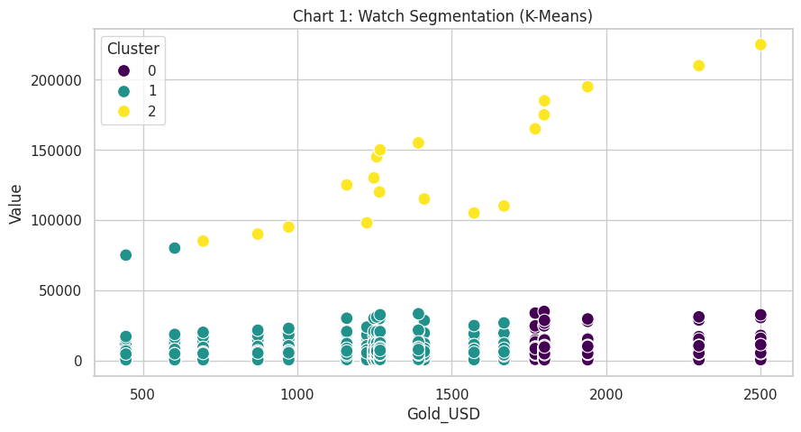
Chart 1: Watch Market Segmentation — K-Means clusters plotted by Gold Price vs. Watch Value

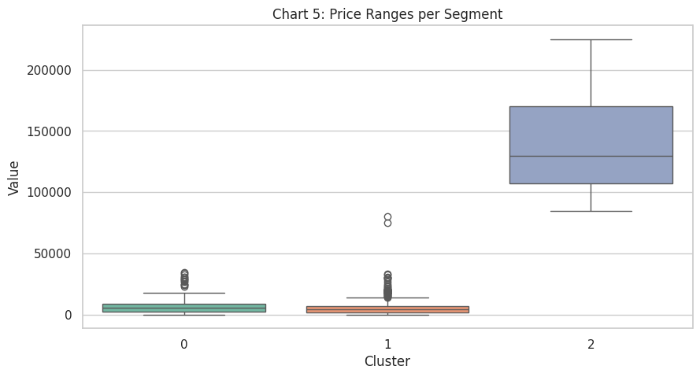
Chart 5: Price Ranges per Segment — Boxplot of watch values by cluster

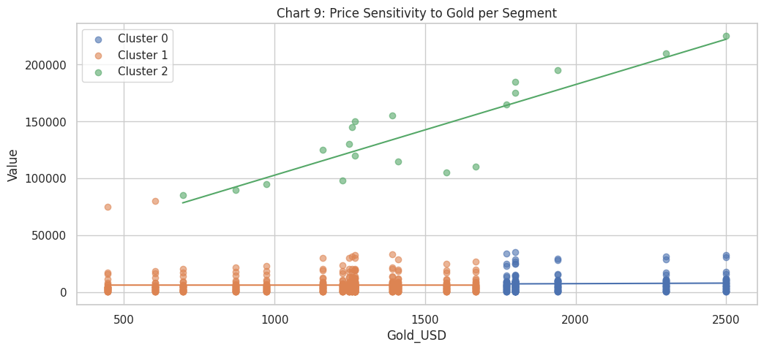
Chart 9: Gold Sensitivity by Cluster — Differential macroeconomic responsiveness across market tiers

4.2 Random Forest Regression
A Random Forest Regressor (100 estimators, random_state=42) was trained on six features: Year, Gold_USD, Nasdaq_Index, S&P500_Index, US_CPI_Index, and Cluster. Dataset split: 80% training / 20% test.

- R² Score: 0.9429 — 94.3% of price variance explained by macroeconomic features.
- Conclusion: H₀ decisively rejected. Macroeconomic indicators are strong and reliable predictors.

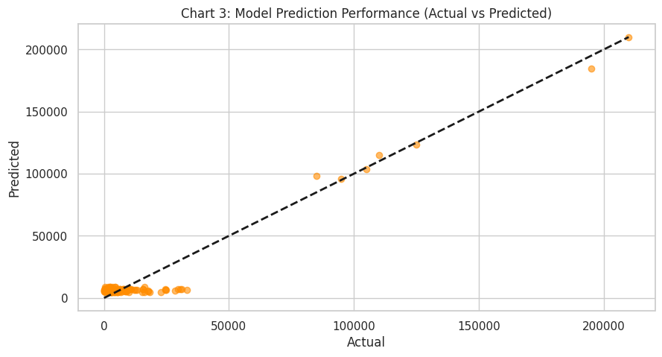
Chart 3: Actual vs. Predicted Watch Prices — Model accuracy visualization (R² = 0.9429)

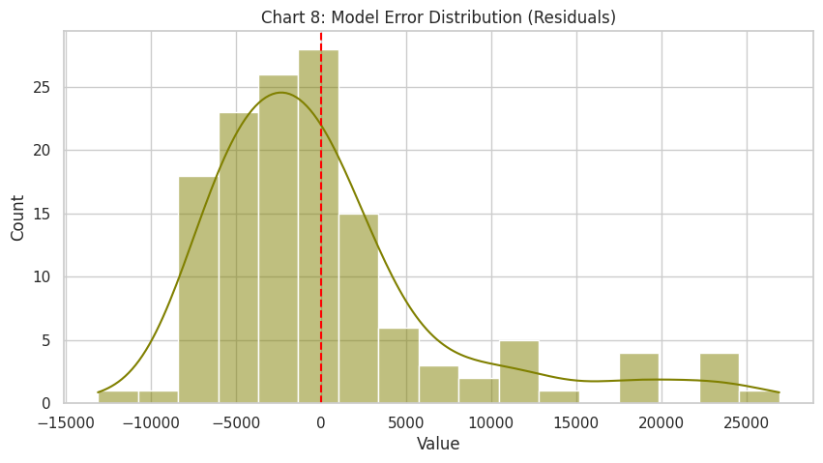
Chart 8: Residual Analysis — Model error distribution confirming low systematic bias

4.3 Feature Importance Analysis
The Random Forest feature importance ranking directly addresses which macroeconomic factors most influence watch prices:
- Gold_USD: Most important feature — confirming H1 and safe-haven hypothesis.
- US_CPI_Index: Second most important — consistent with H2 inflation dynamics.
- S&P 500 & Nasdaq: Significant contributors reflecting wealth effects on luxury consumption.
- Cluster: Engineered cluster feature contributed meaningfully, validating segmentation approach.

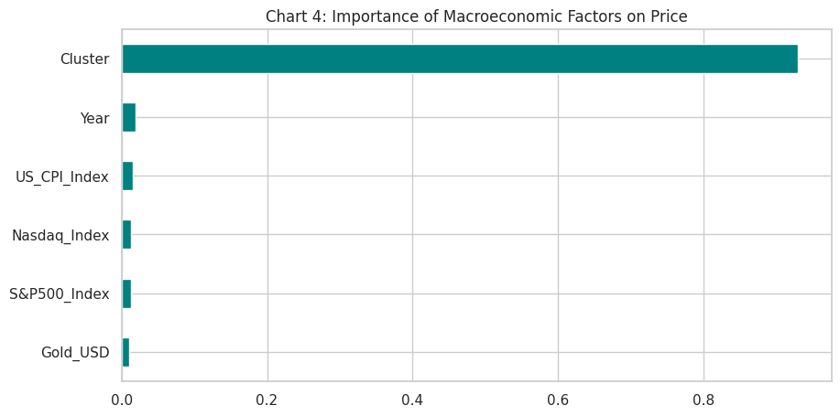
Chart 4: Feature Importance — Ranked macroeconomic variable weights from Random Forest

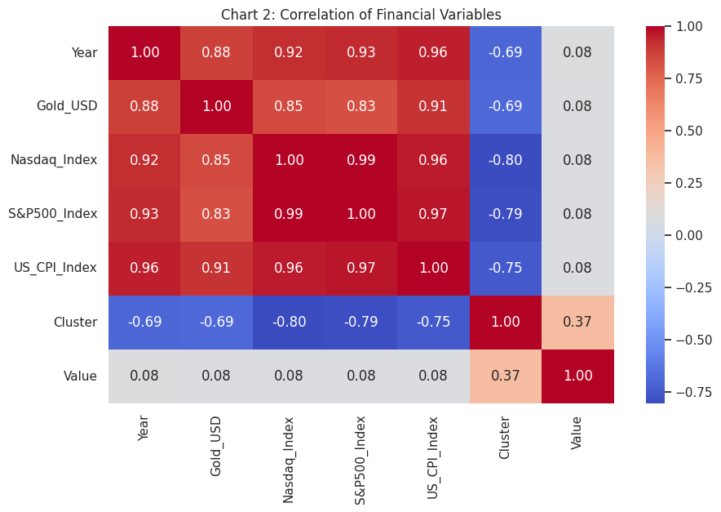
Chart 2: Correlation Heatmap — Pearson correlations between all features and watch prices

4.4 Price Trends and Distribution
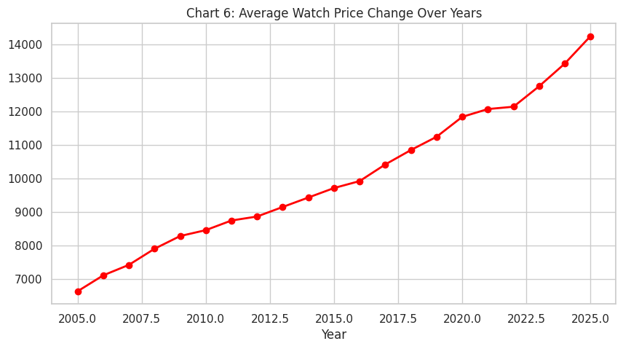
Chart 6: Average Watch Price Trend Over Time (2005–2024)

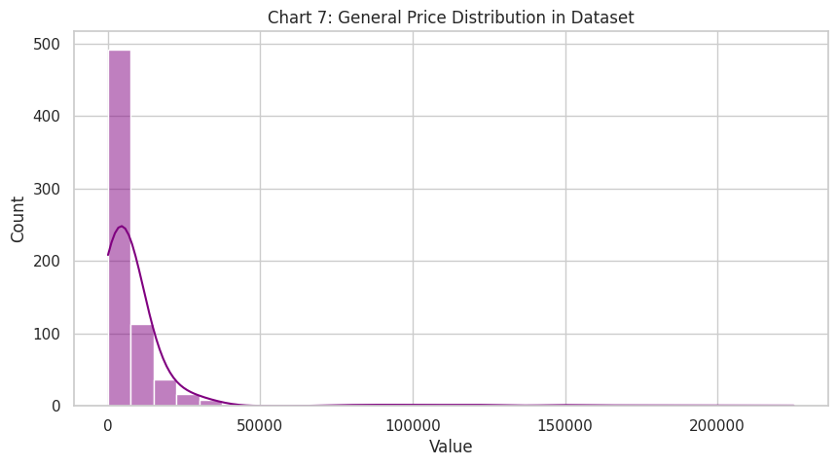
Chart 7: Overall Price Distribution in Dataset — Histogram with KDE overlay

4.5 Future Scenario Prediction
The trained model was applied to a hypothetical 2027 scenario (Gold_USD = $2,850; Nasdaq = 19,500; S&P 500 = 5,800; CPI = 120; Cluster 2), demonstrating the model's practical utility for forward-looking market analysis.

5. Limitations

5.1 Retail Price vs. Secondary Market
The dataset tracks official retail prices rather than auction or secondary market values. For ultra-luxury models such as the Patek Philippe Nautilus and Rolex Daytona, secondary market premiums can reach 200–400% above retail, meaning the full speculative dynamics of the collectibles market are only partially captured.

5.2 The Richard Mille Effect
The Richard Mille RM011 is a consistent statistical outlier with prediction errors exceeding $70,000. Its pricing is driven by celebrity endorsements and ultra-limited production runs that transcend conventional macroeconomic modeling.

5.3 Currency and Geographic Scope
All prices are denominated in USD. Watch prices in local currencies may diverge substantially due to exchange rate fluctuations, tariffs, and regional distribution strategies.

5.4 Qualitative Drivers
Limited-edition releases, celebrity collaborations, waitlist dynamics, and collector taste shifts remain outside the model's scope. The viral demand surge for the Patek Philippe Nautilus post-2017 was driven by cultural factors not captured in macroeconomic time series.

5.5 Temporal Constraints
Annual price data smooths over within-year volatility. High-frequency price movements during market shocks (2008 financial crisis, 2020 COVID-19 pandemic) are averaged out and may underrepresent short-term macroeconomic sensitivity.

6. Summary and Conclusions
This project investigates the macroeconomic determinants of luxury watch prices across 20 years using 35 iconic models and five macroeconomic indicators. The full analytical pipeline yields the following conclusions:

- H1 Confirmed — Safe-Haven Behavior: Gold price is the single most important predictor, validating that luxury watches function as alternative stores of value.
- H2 Partially Confirmed — Real Appreciation: Ultra-luxury tier price increases significantly exceed inflation, indicating genuine real appreciation for top-tier collectibles.
- H3 Confirmed — Market Segmentation: K-Means clustering successfully partitioned the market into three behaviorally distinct clusters.
- H₀ Rejected: R² = 0.9429 demonstrates that macroeconomic variables explain over 94% of the variance in luxury watch prices.

The study concludes that luxury watch prices are not arbitrary. They are systematically linked to the global macroeconomic environment — particularly gold markets and equity performance — with practical implications for collectors, investors, and auction houses seeking data-driven valuation frameworks.

7. AI Usage
Artificial Intelligence tools — specifically Claude (Anthropic) — were utilized as a technical and analytical assistant throughout this project:

7.1 Code Development and Debugging
- Designing the data merging and pivot logic for combining finance and watch price data.
- Implementing the StandardScaler and KMeans pipeline for market segmentation.
- Structuring the Random Forest Regressor with proper train/test split and feature engineering.
- Building the 9-chart visualization dashboard with consistent styling.

7.2 Statistical Methodology
- Confirming the use of K-Means clustering for unsupervised market segmentation.
- Discussing feature importance interpretation in Random Forest models.
- Advising on residual analysis as a model validation technique.

7.3 Documentation
- Structuring the report in accordance with professional data science project standards.
- Formulating precise academic language for hypothesis statements and methodology descriptions.

Note: All AI-generated code and suggestions were manually reviewed, tested, and modified by the author to ensure accuracy and alignment with the project's specific dataset and research objectives.

